Accessorize Your Smartphone or Tablet
Smart Add-ons That Guarantee Great Video and Audio for Your Social MultiMedia Projects!
Kerry Shearer | 2014

Selfie |  | What It Is/What It Does | Cost
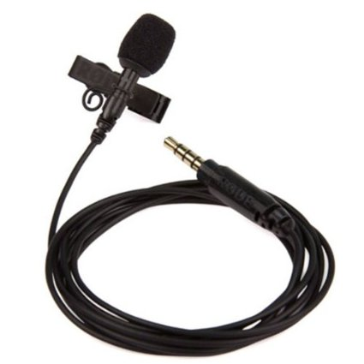 |  | Rode SmartLav  This is a lavaliere (clip-on) wired microphone made just for smartphones and tablets. It will give you great audio! The plug is the special “TRRS” plug that matches the mic/headset jack specific to smartphones and tablets. | $60
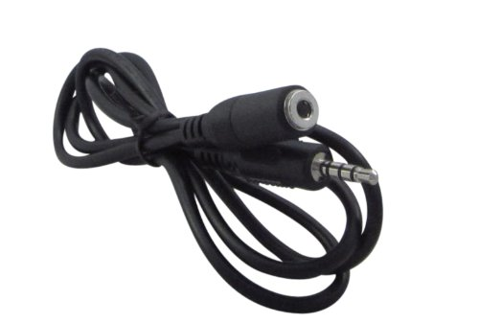 |  | Extension Cable for SmartLav  You’ll want to get one or two of these to extend the length of the SmartLav’s cable. Not just any cord will do: this has “TRRS” connectors on it, just like the SmartLav, which matches the connectors on smartphones and tablets. | $3 - $6
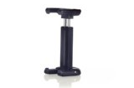 |  | Joby GripTight  This is a small mounting clip that grips your phone securely and allows you to fasten your smartphone to any standard video tripod. | $15
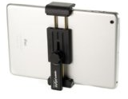 |  | Square Jellyfish Mini Tablet Tripod Mount  This is similar to the GripTight, but larger, allowing you to mount larger smartphones and small tablets (like the iPad Mini) up to 7” in size to a standard video tripod. | $18
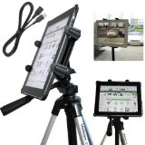 |  | Charger City 9” iPad/Tablet Tripod Mount  This is similar to the Jellyfish, but larger, allowing you to mount full-size iPads and tablets to a standard video tripod.  There are other iPad mounting solutions out there; this is one of the lowest-cost. | $25
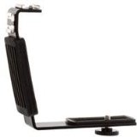 |  | Heavy-duty “L”-Bracket  Mount the Joby GripTight to this handle, snap in your smartphone, and you have a steadier platform for handheld shots. Includes accessory shoes for things like a video light. | $8
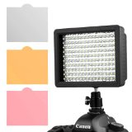 |  | Chromo 160-light LED Video Light  This battery-operated light is perfect for video interviews. It has an adjustable dimmer so you can dial in just the perfect amount of light to make your interviewee look fabulous. | $28
For your convenience, all of these items are on my Amazon Associates store at:
www.CommunicatorsTechStore.com
(sold and shipped directly through Amazon)

