Smartphone/Tablet Video Styles You Can Easily Do!

1 |  | Direct-to-Camera
Characteristics:  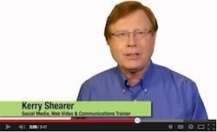 |  | THE STYLE: A “Talking Head” expert or spokesperson for your company delivers valuable information about a topic  -Your talent looks directly into the camera and delivers the information direct to the viewer with passion and authenticity  -This approach works great for how-to videos, demonstrations, event promos, and “news” updates

2 |  | Interview
Characteristics:  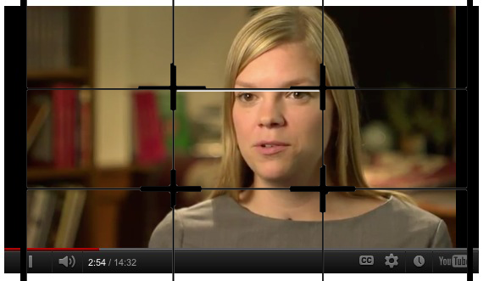  (Hint: Use Rule of Thirds  framing for your subject) |  | THE STYLE: This is an interview of a Subject Matter Expert, or perhaps a client giving a testimonial about the great service they received from your business  -You would use this style if you were trying to collect some video bites to use either as stand-alone comments on a web site, social media page or to distribute to media. Or, you may also want to incorporate their response(s) into a more comprehensive video.  -Typically, the person being interviewed looks at the unseen, off-camera interviewer. A variation on this would be to shoot the video as a “two-shot” with both the interviewer and interviewee on camera at all times.

3 |  | Package
Characteristics:  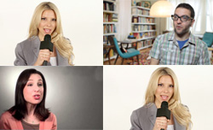 |  | THE STYLE: This is a classic news-style report package: an interview or two sandwiched between an open and close from the “reporter” or spokesperson  -The format is: two or three opening lines from your on-camera “reporter” or spokesperson, followed by one to three brief comments from interviewees, and concluding with a wrap-up from the on-camera “reporter” or spokesperson  -Each speakers’ name is overlaid during editing using a lower-third graphic or text

4 |  | Photo Show or Video Clip Show
Characteristics: |  | THE STYLE: A moving photo show with music or narration. Many of us take lots of photos at our events. This is a great way to use them!  -You can use photos in your phone or tablet’s Camera Roll assemble a quick slide show to show people what the event was like  -Use production music that comes with the editing app, or record an audio narration
Kerry Shearer 2015

